Tracking the Ups and Downs: Pressure Trends in 2024

Abstract
Over the years from 2013 to 2024, the average temperatures have shown a clear warming trend. Back in 2013, January's average temperature hovered around 9.9°C, while July peaked at 24.2°C. Fast forward to 2024, and January warms up to about 10.3°C, with July reaching a higher average of 28.6°C. This gradual increase in temperatures, especially during winter months like January, suggests a shift towards milder winters and hotter summers. Such changes could influence local weather patterns, ecosystems, and even daily activities, highlighting the broader implications of climate change as it reshapes our environment.
Here are three keywords that best summarize this conversation:
1. **Pressure Fluctuations**: Highlights the variations in atmospheric pressure throughout 2024, noting the months with the highest and lowest readings.
2. **Temperature Trends**: Focuses on the change in average temperatures from 2013 to 2024, indicating a warming pattern over the years.
3. **Climate Change**: Reflects the overarching theme of how atmospheric and temperature changes indicate broader shifts in climate patterns.

Compare minimum and maximum pressure values in 2024.
In 2024, the atmospheric pressure experienced some noticeable fluctuations. Let's break it down by month to see the highs and lows:
- January had the highest pressure of the year, reaching 1035.77 mbar, while the lowest was 992.64 mbar.
- February saw a slightly lower peak at 1031.56 mbar, with a minimum of 991.88 mbar.
- In March, the pressure ranged from 1025.16 mbar to 1002.06 mbar.
- April had a high of 1025.99 mbar and a low of 1001.14 mbar.
- The pressure in May was more stable, maxing at 1019.55 mbar and dropping to 1004.18 mbar.
- June experienced a range from 1018.39 mbar to 1003.76 mbar.
- July had slightly lower maximum pressure at 1017.55 mbar and a minimum of 1004.15 mbar.
- August followed closely with a max of 1017.61 mbar and a min of 1004.84 mbar.
- The pressure in September climbed up to 1021.46 mbar, dipping down to 1002.06 mbar.
- In October, the pressure ranged between 1027.94 mbar and 998.78 mbar.
- November saw a high of 1035.65 mbar, close to January's peak, and the lowest was 997.91 mbar.
- Finally, December matched January's peak at 1035.72 mbar, with a minimum of 994.19 mbar.
Overall, the highest pressure readings occurred in January, November, and December, while the pressure dipped lowest in October. This pattern suggests that the year began and ended with relatively stable high pressure, with a slight dip in the middle months. High atmospheric pressure often correlates with clear and calm weather, while lower pressure can indicate stormier conditions.
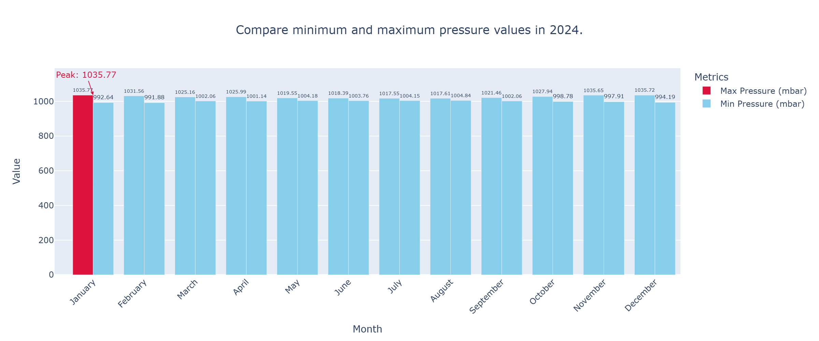

How did the average temperature change from 2013 to 2024?
Let's take a look at how the average temperatures have changed over the years from 2013 to 2024. Think of it like a slow dance between the seasons, with each year having its unique rhythm.
Starting in 2013, the average temperatures were relatively moderate, beginning at around 8.6°C in January and climbing to about 25.7°C by July. Fast forward to 2024, and we see a noticeable shift. January starts warmer at approximately 10.3°C and peaks at around 28.6°C in July.
Over these years, the overall trend shows an increase in average temperatures. Specifically, the cold months like January and December have become warmer, indicating a potential warming pattern. For instance, January's average temperature has risen by nearly 2°C, and July's average temperature has increased by about 3°C.
These changes might suggest a warming trend over the years, which could impact local weather patterns, ecosystems, and even daily life, as hotter summers and milder winters become more common. It's a reminder of how our climate is slowly shifting, and it invites us to think about how these changes might affect us in the future.
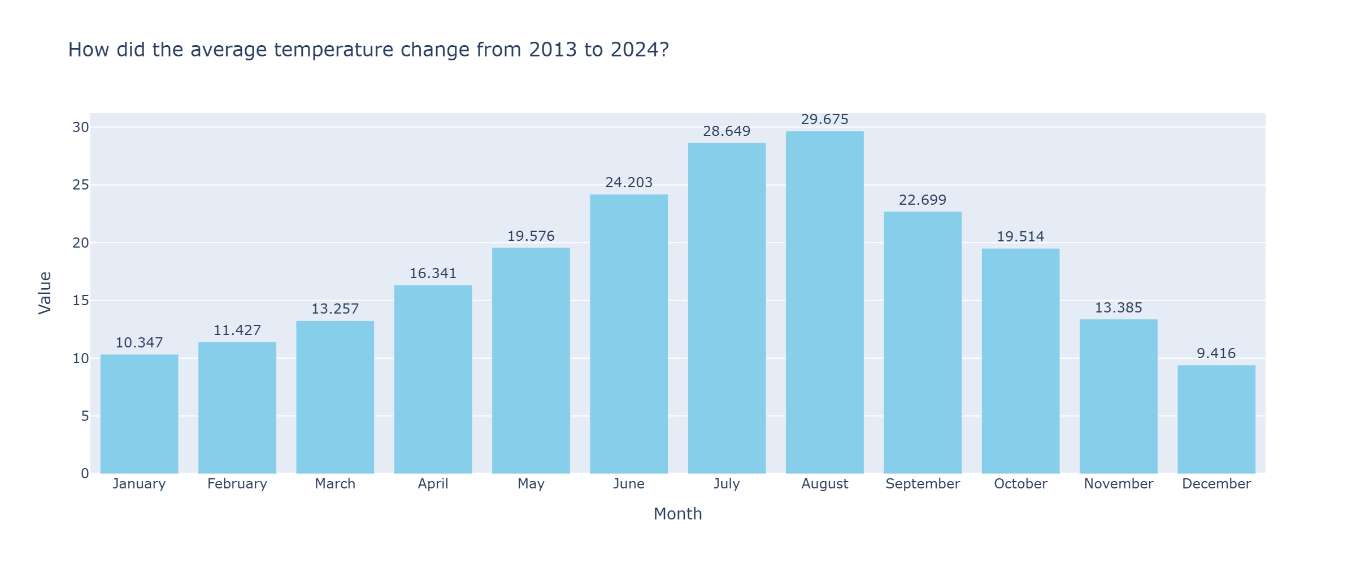

Conclusion
In comparing the minimum and maximum pressure values for 2024, we see a year characterized by noticeable fluctuations in atmospheric pressure. January, November, and December experienced the highest pressure readings, with peaks reaching around 1035 mbar, suggesting periods of stable and calm weather. On the other hand, the lowest pressure was recorded in October, dipping to about 998 mbar, which might indicate more unsettled, stormier conditions during this month. Overall, 2024 began and ended with relatively high pressure, hinting at generally clear weather, while the middle months saw variations that could introduce changes in local weather patterns.
Looking at the change in average temperature from 2013 to 2024, there's a clear warming trend. In 2013, temperatures were moderate, starting at around 8.6°C in January and peaking at about 25.7°C in July. By 2024, January's average temperature increased to approximately 10.3°C, and July's climbed to 28.6°C. This gradual rise in temperatures, especially in colder months, suggests a shift towards warmer winters and hotter summers. These changes can influence local ecosystems and everyday life, potentially leading to more frequent heatwaves and altered seasonal patterns, reminding us of the ongoing impact of climate change.

